[](http://thehub.royallondongroup.com/)

 

Test Approach

BI Test Team

v1.0

VERSION CONTROL

|  |  |  |  |  |
| --- | --- | --- | --- | --- |
| Version | Date | Author | Comment | Changes Marked? |
| 0.5 | 28/08/2019 | Keith Mackenzie | Original version updated to fit the template and new content added. | N |
| 0.6 | 24/09/2019 | Keith Mackenzie | Updates made based on peer review from BI team and Practice Lead. | N |
| 1.0 | 25/09/2019 | Keith Mackenzie | Updated to V1.0 after sign off. | N |

SIGN-OFF

|  |  |  |
| --- | --- | --- |
| Action | People | Date Completed |
| Initial draft issued to internal project team for peer review | Mahitha Kolli, Manoranjitham Thirugnanam, Aileen Galvin | 04/09/2019 |
| Peer reviewed | Mahitha Kolli, Manoranjitham Thirugnanam, Aileen Galvin | 04/09/2019 |
| Final draft issued to full project team | Mahitha Kolli, Manoranjitham Thirugnanam, Aileen Galvin, Fraser Stark, Suganthi Kalaiarasan, David McChang, Del Blowman, Dave Carter, Richard Brown | 13/09/2019 |
| Walkthrough with project team | Mahitha Kolli, Manoranjitham Thirugnanam, Aileen Galvin, Fraser Stark, Suganthi Kalaiarasan, David McChang, Del Blowman, Dave Carter, Richard Brown | 13/09/2019 |
| Sign off | [Kirstin Forder](http://gfportal/groupbusinessintelligence/Technical%20Papers/BI%20Testing/Test%20Approach/Sign%20Off/BI%20Test%20Approach%20sign%20off.msg) | 26/09/2019 |

DISTRIBUTION

|  |  |
| --- | --- |
| Name | Role |
| Kirstin Forder | Practice Lead |
| Richard Brown | Technical Lead |
| Dave Carter | Technical Lead Developer |
| LTA Peer Reviewers | Lead Test Analyst |
| Mahitha Kolli, Manoranjitham Thirugnanam, Aileen Galvin, Amrutha Hyaliz | Test Analyst(s) |
| Fraser Stark, Suganthi Kalaiarasan, David McChang, Del Blowman, Pete Kilpatrick | Developer(s) |

REFERENCES

|  |  |
| --- | --- |
| **Document** | **Source / Location** |
| Business Requirements | n/a |
| Non-functional Requirements | n/a |
| Application Design | n/a |
| BI Test Approach Diagram | [BI Test Approach](http://gfportal/groupbusinessintelligence/Technical%20Papers/BI%20Testing/Test%20Approach/BI%20Test%20Approach%20Visual%20Diagram.xlsx) |
| BI Test Approach Visuals | BI Test Approach Visuals |
| Azure DevOps/MTM Standards | [Azure DevOps/MTM Guide](http://rliprojects-portal/standards/testing/Shared%20Documents/Microsoft%20Test%20Manager/MTM%20guide.docx) |
| Organisational Test Strategy (OTS) | [Organisational Test Strategy](http://rliprojects-portal/standards/testing/Shared%20Documents/Test%20Governance%20Documents/Organisational%20Test%20Strategy.docx) |

**CONTENTS**

1 INTRODUCTION 6

1.1 Background 6

1.2 Purpose 6

PROJECT SCOPE 7

1.3 In scope 7

1.4 Out of scope 7

2 Test approach 8

2.1 V Model or Agile 8

2.2 Approach and Techniques 8

2.2.1 Project Flow 9

2.2.2 How we test BI 10

2.3 Test automation 11

2.4 Cross Browser and Device Testing 11

2.5 Performance Testing 11

2.6 Operational Acceptance Testing 11

2.7 Onshore/Offshore Testing 11

2.8 Security Testing 12

2.9 Test Phases and Objectives 12

2.10 Test Releases and Cycles 16

2.11 Test Analysis and Design 16

2.13 Test Pack 17

2.14 Testing Types/Techniques 17

3 Risk Assessment 18

3.1.1 Quality Assurance 18

3.2 RAIDs 18

3.2.1 Risks & Issues 18

4 Test Data 19

4.1 Data Requirements 19

4.2 Data Population 19

5 Management & Quality Controls 19

5.1 Roles and Responsibilities: 19

5.2 Skills and Resource Requirements 20

5.3 Reporting 20

5.3.1 Progress Reporting 20

5.3.2 Test Completion Report 20

5.3.3 Quality Criteria 21

5.3.4 Reviews 21

5.4 Communication/Meetings 22

5.5 Post Implementation Support 22

6 Glossary 23

7 Appendices 24

7.1 Test Plan example 24

# INTRODUCTION

## Background

The Group BI platform was introduced for the Direct 2 Consumer (D2C) business in 2014, and has since been extended to include data for GCS, Protection and Finance. The Business Intelligence (BI) test team are responsible for testing any BI related work on a project or Business As Usual (BAU) BI activities.

## Purpose

The purpose of this document is to communicate, understand and agree the scope, the objectives, the methods, the resources and responsibilities required to successfully assure the quality of the changes to be implemented by the BI test team.

The BI test team will be responsible for adhering to the Organisational Test Strategy (OTS) and the agreed test approach will give the customer the necessary confidence that the results will be robust and will meet their requirements.

This document will be baselined and signed off once agreed by all parties. It is not a working document and neither provides detail related to planned test cycles, nor the number of cases and execution schedule. This level of detail can be found in the test plan (n.b. a separate performance test plan will be produced).

# PROJECT SCOPE

## In scope

The following items are within the scope of the BI test team:

|  |  |
| --- | --- |
| **Area** | **Description** |
| Consumer | D2C including all the partnerships. |
| POMS | Post Office Management Systems. |
| Protection | Protection division. |
| BAU Activities | BAU changes for all of the above. |
| Avaya | Avaya analytics for GCS. |
| Google Analytic Premiums | Royal London web analytics. |

## Out of scope

|  |  |  |
| --- | --- | --- |
| **Area** | **Description** | **Reason not in Scope** |
| Think Beyond | The ThinkBeyond programme will replace the current pension administration system (Oryx) with a new Pensions platform. | Testing is currently carried out by the Think Beyond team. It will become in scope when the first release is delivered and becomes BAU. |
| Finance | Finance has its own projects that are not tested by the BI team. | Testing is carried out by Cognizant. |
| Data Sources | The original source of the data used in the ETL process. | The corresponding team of each source system will be responsible for data ingestion and assuring the quality of data. |

# 

# Test approach

## V Model or Agile

The BI test team will use elements of the Agile project management method for all stages of testing. We follow the Kanban methodology, releasing approximately every 2 weeks. The stages before testing are more waterfall due to the nature of the work. We currently have no BA in the team and do not have much contribution to the creation of the requirements, but carry out static testing on them.

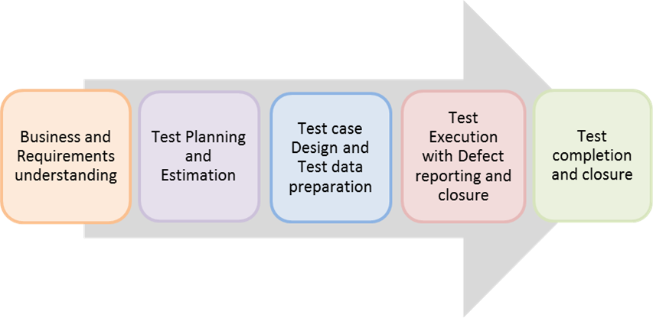

## Approach and Techniques

The standard approach in the BI test team is to test the black box of the ETL. A recent example (from Price Optimisation) can be found in the Appendices.

The ETL (Extract, Transform, Load) validation process is about taking data from source (which can be a flattened file from source tables or data from tables themselves), cleaning it up in a temporary staging area, and then pushing it into the destination tables.

Data is validated at each stage from the data sources through each step of the extract and transformation process including the final load to the destination tables to be used for export files (e.g. Price Optimisation) and the reporting system Tableau.

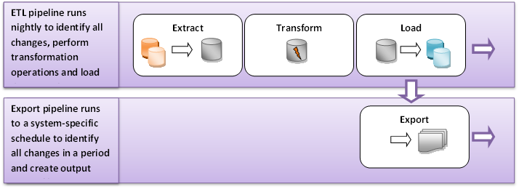

### Project Flow

### 

### How we test BI

Testing BI is different from traditional application testing as it requires a data centric approach.

**Source**

* Identify the source data in the Landing stage. This may involve entering test data via a portal or using test data already available in the database.
* Manipulate specific source data (change table values) to meet input criteria. Test data must be set up to match input conditions defined in the test plan.

**Staging**

* Run the SQL Agent jobs (specific to the database) manually to invoke SSIS staging package
* Check the staging package runs successfully
* Verify the data in the staging tables

**Destination**

* Run the SQL Agent jobs (specific to the database) manually to invoke SSIS Destination package
* Check the destination package runs successfully
* Verify the transformed load of records at destination
* Verify any incremental loading of records at a later date from newly inserted or updated records.
* Validate the data in Catalogue tables and views
* Confirm format and contents of extract , SSRS and export files

**Export**

* Run SQL Agent jobs manually to invoke SSIS jobs
* End-users to validate export files

## Test automation

The [Automation Decision Tree](http://rliprojects-portal/standards/testing/Shared%20Documents/Automated%20Testing/RL%20Automation%20Decision%20Tree.docx) has been referenced when formulating the test approach. Currently there is not test automation in place, but we are looking at introducing it in the near future.

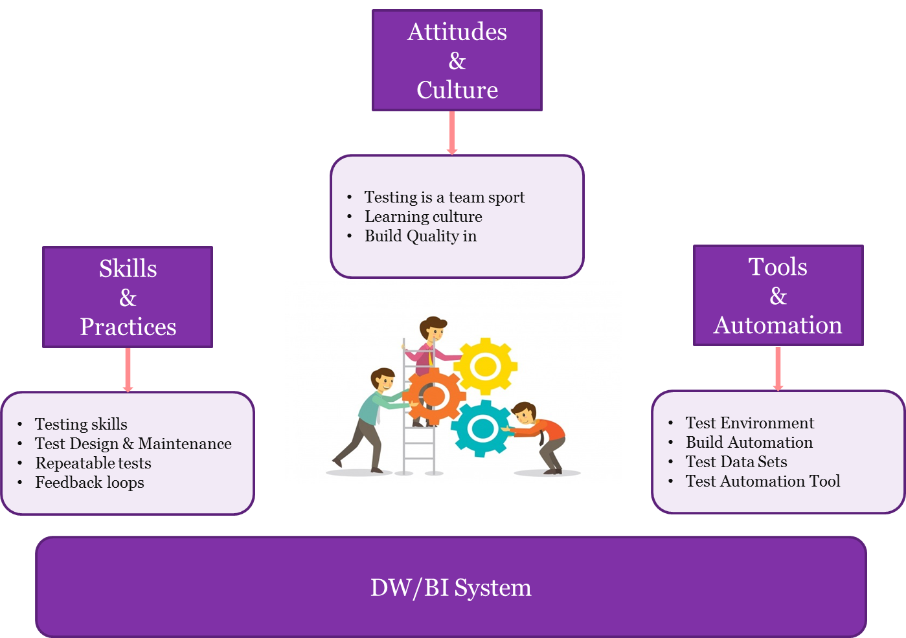

## Cross Browser and Device Testing

Cross Browser testing is out of scope for the BI test team as data only held in the enterprise Data warehouse is in scope for testing.

## Performance Testing

For each piece of work the BI test team will identify early if there is any need for performance testing and liaise with the Performance team, who will outline the approach. The goal of performance testing is to optimise session performance by eliminating performance bottlenecks that can be found in source and target databases, mapping, session and the system.

## Onshore/Offshore Testing

The BI test team is currently all onshore.

## Security Testing

For each piece of work the BI test team will identify early if there is any need for security testing and liaise with the IT Security team, who will outline the approach.

## Test Phases and Objectives

All test phases are mandatory apart from Model Office and performance testing. For each piece of work the BI test team will identify early if there is any need for these and liaise with the relevant team.

|  |  |  |  |
| --- | --- | --- | --- |
| **Requirements Test Phase – Environment n/a** | | | |
| Entry/Exit | Criteria | Owner | Quality Gate Owner |
| Entry | * Requirements documented and reviewed by project team * Requirements prioritised for risk assessment and test planning * Non-functional requirements documented and reviewed by project team | TA | LTA |
| Exit | * Static testing completed on all requirements * Test conditions signed off by project team | TA | LTA |

|  |  |  |  |
| --- | --- | --- | --- |
| **Unit Test Phase – Local Build Environment** | | | |
| Entry/Exit | Criteria | Owner | Quality Gate Owner |
| Entry | * Requirements reviewed and signed off by project team * Internal code review completed | AP | Lead AP, LTA |
| Exit | * Unit testing completed and all automated scripts pass * Code peer reviewed | AP | Lead AP, LTA |

|  |  |  |  |
| --- | --- | --- | --- |
| **System Test Phase – Project Local Environment** | | | |
| Entry/Exit | Criteria | Owner | Quality Gate Owner |
| Entry | * Unit Test completed by the assigned developer and evidence available * Code review performed by developer * System/SIT test cases peer reviewed by member of the test team * Appropriate test data available in test environment * Code deployed to appropriate test environment * Skim test of environment successfully completed * Business requirements reviewed and signed off * Source environments available and are in sync | TA | LTA |
| Exit | * All test scripts executed and at a status of passed * All related defects at a status of closed * Any open defects have been risk assessed and accepted for go live * Test results peer reviewed by a member of the test team * Test completion report updated * Sign off email sent to developer, development lead and member of test team | TA | LTA |

|  |  |  |  |
| --- | --- | --- | --- |
| **Integration Test Phase – UAT Environment** | | | |
| Entry/Exit | Criteria | Owner | Quality Gate Owner |
| Entry | * System Test exit criteria have been met * System/System Integration Testing Complete * Deployment to UAT environment signed off by member of the release management team * Skim test of environment successfully completed * Business resource secured to participate in User Acceptance Testing if applicable * Appropriate test data available in test environment * Code deployed to appropriate test environment | TA | LTA |
| Exit | * All UAT test scripts executed and at a status of passed * All related defects at a status of closed * Any open defects have been risk assessed and accepted for go live * Business user sign off received if applicable * Test completion report updated * Sign off email sent to developer, development lead and member of test team | TA | LTA |

|  |  |  |  |
| --- | --- | --- | --- |
| **Performance Test Phase – Performance Test Environment** | | | |
| Entry/Exit | Criteria | Owner | Quality Gate Owner |
| Entry | * Performance testing identified as being required for change * Performance test plan signed off by project team * Performance test scripts signed off by project team * Code deployed to appropriate test environment * Skim test of environment successfully completed * Production sized data set available to perform accurate tests | PTA | PTA, LTA, SA, Lead AP |
| Exit | * All performance test scripts executed and at a status of passed * No defects outstanding * Test completion report updated * Sign off email sent to developer, development lead and member of test team | PTA | PTA, LTA, SA, Lead AP |

|  |  |  |  |
| --- | --- | --- | --- |
| **Pre-Production Test Phase – PRE Test Environment** | | | |
| Entry/Exit | Criteria | Owner | Quality Gate Owner |
| Entry | * User Acceptance/Performance Testing completed * Deployment to PRE environment signed off by member of the release management team * Code deployed to appropriate test environment * Skim test of environment successfully completed | TA | LTA |
| Exit | * All PRE test scripts executed and at a status of passed * Test completion report updated * Sign off email sent to developer, development lead and member of test team * Any defects deferred to a later release have been risk assessed * Test completion report reviewed and signed off | TA | LTA |

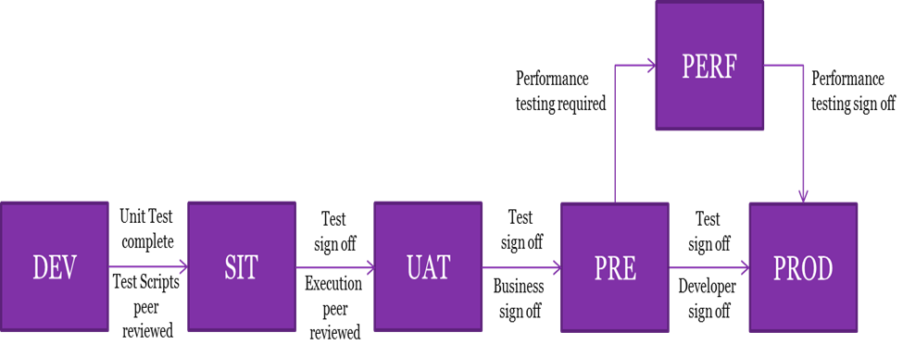

## Test Releases and Cycles

Testing will be broken down into a series of releases and cycles influenced by the results of the risk assessment. For small change items/BAU changes we aim to release every 2 weeks. For large change items they will run over several weeks/months or in line with the project implementation date the change is connected to.

These releases and cycles will be documented in Microsoft Azure DevOps.

## Test Analysis and Design

Requirements documents form the basis for test analysis. This process is the detailed test Analysis and Design required for the production of test artefacts to be used in test execution. It is vital that requirements are clear, agreed and signed off prior to testing commencing – this involves requirements being documented, tested and accepted. This is a vital input to risk-based test planning.

| **Deliverable Type** | **Purpose** |
| --- | --- |
| Static Testing | Output created to provide constructive feedback on the identified test basis. |
| Azure Dev Ops Test Structure | A representation of the planned testing in Azure Dev Ops utilising the Azure Dev Ops guideline. |
| Test Conditions/Acceptance Criteria | Definition at the lowest level of the conditions to be tested. |
| Test Scenarios/Test Cases | Collection of test conditions in to a logical and executable test. |
| Manual Test Scripts  (not necessarily produced where automation is applicable) | A set of instructions that will be performed by a tester on the system under test to verify if the system or its features is working as intended. |
| Automation Test Scripts | Where tools are used to execute a test as opposed to a tester. |

## Test Pack

The test pack will be recorded on Azure Dev Ops and will follow the standards for BI, which can be found [here](http://gfportal/groupbusinessintelligence/Technical%20Papers/BI%20Testing/Continuous%20Improvement/Test%20Standards.xlsx).

All tests in the Azure Dev Ops test plans will be linked back to PBIs, thereby providing visibility of coverage and traceability.

## Testing Types/Techniques

The [OTS](http://rliprojects-portal/standards/testing/Shared%20Documents/Testing%20Methods/Divisional%20Test%20Strategy/Organisational%20Test%20Strategy.docx) has details of all test types/techniques and the test phases in which they can be applied. For the BI Test Team the following table shows which are to be applied and why:

| **Test Phase** | **Test type/technique** | **Reason** |
| --- | --- | --- |
| Requirements testing | Static – document review, walkthrough. | It is vital that requirements are clear, agreed and signed off prior to testing commencing – this involves requirements being documented, tested and accepted.  This is a vital input to risk-based test planning. |
| Unit Test | Unit testing by Developer | Required. |
| DEV (System) | 1. Skim 2. Manual testing 3. Break Testing 4. Regression | 1. This is to ensure that no issues are found after the initial build of the environment, or after subsequent releases. 2. System Testing is the validation process to ensure the data integrity is met across the different ETL layers. 3. Break testing is performed on user stories with complex and high risk from business perspective through scripted manual testing 4. Regression Testing takes place following code-merge and validates the changes to make sure that the original functionality still work. Specific test Scripts identified will be built into a regression suite. |
| UAT (Integration) | 1. Skim 2. Manual testing | 1. This ensures that code has been shipped correctly from DEV into the UAT environment 2. A targeted selection of the scripts executed in system testing will be run on UAT |
| PRE (Pre Production) | 1. Skim 2. Manual testing | 1. This is carried out to ensure that code has been shipped correctly from UAT into the PRE environment. 2. A targeted selection of the scripts executed in system testing will be run on PRE. |

# 

# Risk Assessment

For each change a risk assessment will be carried out against the high-level requirements to identify the areas carrying the most significant risk (Probability x Impact). The risk assessment is used to drive the approach to testing.

Higher risk equates to greater attention on assuring the quality of the specific item, which will drive a number of initiatives:

* Deliver (and test) as early as possible
* The use of appropriate test techniques (checks against expectations) as early as possible in the project lifecycle (e.g. walkthroughs, reviews etc.)
* Stakeholder commitment to contribute themselves and/or involve SMEs (Subject Matter Experts) in early validation exercises in order to allow early identification of issues
* Increased test coverage for the higher risk items

### Quality Assurance

Depending on the size of the change, matrices of the test conditions for each implementation will be prepared by the test analysts and reviewed by both SMEs within the project team and the business. The test matrices will be linked back to the requirements. All test scripts will be peer reviewed to ensure these meet quality standards and provide full coverage of the conditions in the test matrix.

## RAIDs

### Risks & Issues

Risks and issues will be recorded on the project risk log. There is also a RAID log for the BI team as a whole, which can be found [here](http://gfportal/groupbusinessintelligence/BI%20Projects/Risk/BI%20-%20RAID%20Log.xlsx).

Any changes in scope will be logged via the Change Control process.

# Test Data

## Data Requirements

The test data will be sourced from the relevant source system. Test data can also come from flat files and SQL tables. The BI test team will work with Business stakeholders to identify the test data required to ensure sufficient data is available.

In some instances test data can be created by the BI test team without comprising the testing, but the preferred option is always to use real test data.

If it is not possible to create / source test data due to time constraints on any particular test environment, then a risk assessment takes place. A caveat is put in place and real test data must be used in 2 out of the 3 test environments.

If there is test data on SIT, but not UAT or PRE, then it is acceptable to sign off with a caveat as at this stage we are just testing the process works.

## Data Population

The approach to test data will be closely aligned to the release cycle. When appropriate, at the start of a release cycle the environment will be cleared down and built to a defined level of code/infrastructure. In order to do this a back fill is performed by the BI test team.

# Management & Quality Controls

## Roles and Responsibilities:

|  |  |
| --- | --- |
| **Role** | **Responsibilities** |
| LTA | * Lead the test team and manage testing tasks * Write the test approach and ensure it is followed at all stages * Undertake relevant test phase sign-offs * Liaise with specialist teams (Performance, Security etc.) to incorporate non-functional testing into the test approach * Plan the daily testing workload and reporting of progress * Remove any blockers that occur during testing |
| TA | * Define test coverage and prioritise tests * Create and execute automated and manual tests * Ensure all defects are allocated, fixed and retested * Promote the automated test framework |
| Performance TA  (PTA) | * Write the performance test plan in conjunction with the LTA * Execute performance testing and assist with test sign off * Work with the project team to ensure that security and operability testing (where required) is executed and signed off |
| BA/Data Analyst | * Contribute to and review test artefacts * Joint responsibility with the AP for reviewing and signing off test coverage |
| AP | * Execute unit testing and provide evidence * Joint responsibility with the BA for reviewing and signing off test coverage * Agree the heat map with the LTA and BA |

## Skills and Resource Requirements

The BI test team would need to have the below detailed skill sets:

* ETL / Business Intelligence / Enterprise Data Warehouse Testing experience
* Testing experience in SSIS packages
* Testing experience in SSRS/Tableau reports
* Create SQL queries, knowledge of complex stored procedures and execute them
* Testing experience on ETL transformations, CDC (Incremental Load)
* System testing, regression testing experience

Training will be required if any testing resource does not have the required skill set (test tools, test process etc.).

## Reporting

### Progress Reporting

All testing metrics will be extracted from Microsoft Azure DevOps. Reports will be available via the LTA. A dashboard will be created for each project.

Reports will use the metrics provided plus additional wording to confirm any particular risks or issues which may delay current or future testing or impact quality.

Depending on the nature and size of the project the reports will include updates on:

* Requirements coverage
* Test preparation progress
* Test execution progress
* Defect trends

In particular the reports will highlight any areas where things are not progressing as planned.

The LTA will provide a verbal update on status at regular project team meetings. Whilst the TA will give a status update at the daily stand up.

### Test Completion Report

Test summary reports will be completed as part of the exit criteria from DEV, UAT, PRE, and Performance testing.

These reports will confirm that all activities have completed as expected based on this document and the project test plan together with providing confirmation of the final metrics for the testing carried out.

These will also highlight any areas where activities have deviated from what was expected based on the test approach (this document) and the project test plan together with reasons why.

There are two templates for Test Completion Reports:

* [Large changes & Projects](http://gfportal/groupbusinessintelligence/Technical%20Papers/BI%20Testing/Test%20Completion%20Report%20Template/Test%20Completion%20Report%20Template%20-%20Large%20Change.docx)
* [Small changes and Bug fixes in the one Release](http://gfportal/groupbusinessintelligence/Technical%20Papers/BI%20Testing/Test%20Completion%20Report%20Template/Test%20Completion%20Report%20Template%20-%20Release.docx)

Bug fixes released on their own do not require a Test Completion Report.

### Quality Criteria

The test pack on Microsoft Azure DevOps will be reviewed periodically to ensure certain minimum standards are met.

Defects will be logged in accordance with the [Defect Severity Guidelines](http://rliprojects-portal/standards/testing/Shared%20Documents/Test%20Governance%20Documents/Defect%20Severity%20Guidelines.doc) and team leaders will ensure that all those using Azure Dev Ops are familiar with the process and standards.

### Reviews

Certain test deliverables are reviewed as part of the project Quality Plan.

| Review Requirement | Review Purpose | Created By | Reviewed By |
| --- | --- | --- | --- |
| Risk assessment | To identify and review the high-level testable items (functional and non-functional) – determining the probability and impact of failure in order to generate the heat map. | LTA | LTA, BI Team |
| Test conditions / cases | To ensure that the high-level test conditions provide coverage of the requirements and demonstrate understanding of the aims of the project. | TA | LTA, TA peer review |
| Test scripts | Manual: Ensure that the scripts are written as per the Azure Dev Ops/MTM guidelines with enough information in them. | TA(s) | LTA, TA peer review |

## Communication/Meetings

|  |  |  |  |  |
| --- | --- | --- | --- | --- |
| Communication type | Frequency | Purpose | Attendees | Owner |
| Project test update (when necessary) | Daily | To provide an update on progress within the wider project. | LTA/TA | LTA |
| Project meeting (when necessary) | Weekly | To discuss project progress and address any issues / risks within the wider project. | PM/LTA/ Lead BA, Lead AP, TA | PM |
| Team stand ups | Daily | To obtain update on progress within the BI team. | BI Team | BI Team |
| Sprint/Release planning | Fortnightly | To plan the team’s work for the next Sprint/Release. | BI Team | BI Team |
| Sprint/Release retrospective | Fortnightly | To review the Sprint/Release and create a plan for improvements to be enacted during the next Sprint/Release. | BI Team | BI Team |
| BI test team catch up | Weekly | To discuss how the team’s week has been in terms of progress, blockers, concerns etc. | Test team | LTA |
| Test Continuous Improvement Meeting | Fortnightly | To ensure we are consistent with the rest of the practice in terms of documentation and processes. | Test team | LTA |

## Post Implementation Support

Any BI post implementation work comes back into the BI team via Ivanti as we are a self-contained function. Any post implementation defect will be retrospectively raised in Azure Dev Ops.

# Glossary

[*http://gfportal/groupbusinessintelligence/Lists/BI%20Glossary/AllItems.aspx*](http://gfportal/groupbusinessintelligence/Lists/BI%20Glossary/AllItems.aspx)

| Term | Meaning |
| --- | --- |
| BI | Business Intelligence |
| D2C | Direct 2 Consumer |
| ETL | Extract Transform Load |
| GCS | Group Customer Services |
| NFT | Non Functional Testing |
| OAT | Operational Acceptance Testing |
| Oryx | RL's existing life and pensions administration system |
| OTS | Organisational Test Strategy |
| PMO | Programme Management Office |
| PRE | Pre-Production |
| RAID | Risks, Assumptions, Issues and Dependencies log |
| RL | Royal London |
| SIT | System Integration Test |
| SME | Subject Matter Expert |
| TCR | Test Completion Report |
| SQL | Structured Query Language |
| SSIS | SQL Server Integration Services |
| UAT | User Acceptance Testing |

# Appendices

## Test Plan example

